TRANSPORT
A mini bus will be operating within Sudbury, Cornard and surrounding villages to collect anyone living with dementia or who suffers from limited or restricted mobility.
There will, be a flat return fare of £4 payable to the driver on the day. Anyone wishing to use this service needs to book in advance by calling GoStart office on 01787 242216.
Spaces will unfortunately be limited so you are advised to make booking arrangements well in advance. All our Mini Busses have wheel chair access. It is very important for anyone travelling in a wheel chair to make that clear at time of booking.
As spaces are limited and demand is high, please ensure that you advise the GoStart office as soon as possible if you are unable to uphold your booking

AUDITORIUM
If you are coming with a large group, please ensure that you arrive at least 20 minutes before the screening.
The space for wheelchairs is limited in the auditorium so it is essential that you advise the Box office of any wheelchair spaces needed within the theatre. Wheelchairs can be stored in the theatre wing if those using one are able to be walked to a fixed seat.
Our dementia friendly screenings have the house lights on low and the volume is kept lower than usual film screenings.
Staff are aware of the need of a ‘safe’ and quiet place within the theatre if needed by any of our visitors.

The Quay Theatre, Quay Lane, Sudbury, Suffolk CO10 2AN / 01787 374745

A SPECIAL MONTHLY MUSICAL FILM SCREENING FOR PEOPLE LIVING WITH DEMENTIA AND THEIR CARERS. Free Entry

(sponsored by The Sudbury Flower Club and McColls Sudbury)
ALL SCREENINGS ARE AT 2.00pm
ONLY BOOKABLE THROUGH THE BOX OFFICE
(01787 374745).

MONDAY 8TH JANUARY Singin’ in the Rain
A spoof of the turmoil that afflicted the movie industry in the late 1920s when movies went from silent to sound. When two silent movie stars', Don Lockwood and Lina Lamont, latest movie is made into a musical a chorus girl is brought in to dub Lina's speaking and singing. Don is on top of the world until Lina finds out.
Gene Kelly, Donald O'Connor, Debbie Reynolds
U | 1h 43min

MONDAY 5th FEBRUARY
Chitty Chitty Bang Bang
While truant from school, young siblings Jeremy and Jemima meet the beautiful Truly Scrumptious (Sally Ann Howes), who falls for their widowed father, Caractacus Potts (Dick Van Dyke), and his various oddball inventions, including the family's noisy rebuilt car, Chitty Chitty Bang Bang. One day at the beach, Caractacus tells Truly and the children a fanciful fable about the villainous Baron Bomburst (Gert Frobe) and his evil designs on the Potts family car.
Dick Van Dyke, Sally Ann Howes, Lionel Jeffries
U | 2h 24min
MONDAY 5th MARCH
On the Town
Fun-loving sailors Gabey (Gene Kelly), Chip (Frank Sinatra) and Ozzie (Jules Munshin) have 24 hours of shore leave in New York City, and they want to make every second count. While Chip hooks up with loudmouth cab driver Brunhilde (Betty Garrett) and Ozzie swoons for prim anthropologist Claire (Ann Miller), Gabey falls in love with an actress he sees in an advertisement, Ivy Smith (Vera-Ellen). Leonard Bernstein, with lyricists Betty Comden and Adolph Green, provides the music. Gene Kelly, Frank Sinatra, Betty Garrett U | 1h 38min

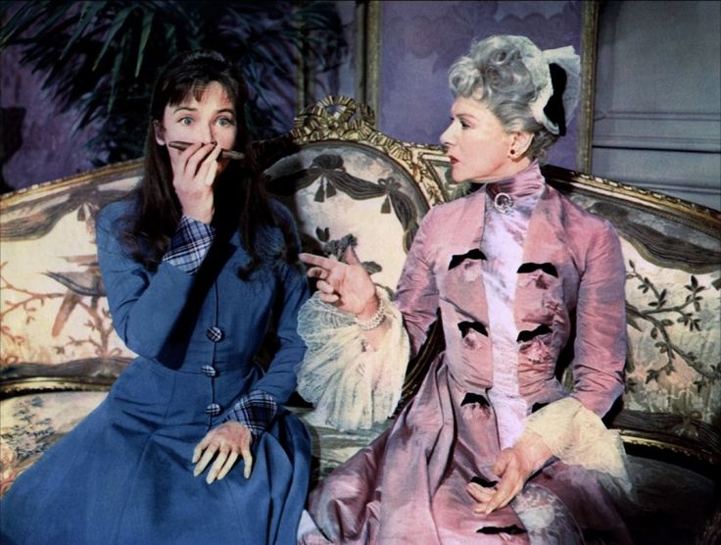
MONDAY 9th APRIL
Gigi
Gaston (Louis Jourdan) is a restless Parisian playboy who moves from one mistress to another, while also spending time with Gigi (Leslie Caron), a precocious younger friend learning the ways of high society. The platonic relationship between Gaston and Gigi changes, however, when she matures, but the possibility of something lasting seems unlikely since he won't commit to one woman. Gigi refuses to be anyone's mistress, however, and Gaston must choose between her and his carefree lifestyle.
Leslie Caron, Maurice Chevalier, Louis Jourdan. A | 1h 55min

