Help vulnerable adults
to enjoy life, make friends
and
have fun
at a weekly ‘Hub’ group in Sudbury
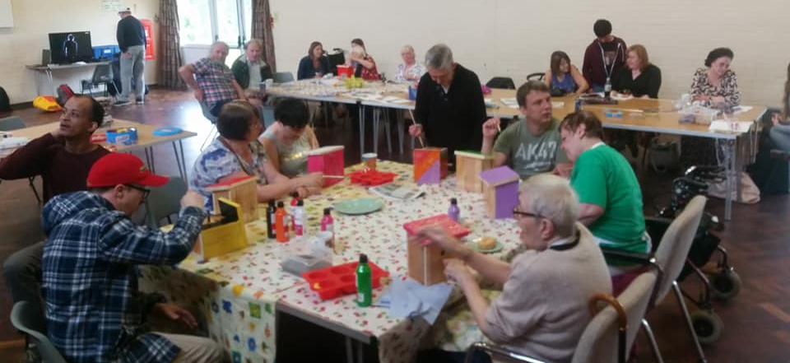
Share your skills, make new friends and improve people’s lives with
just 3 to 6 hours of volunteering once a week
Travel expenses are covered, equipment and free training provided.

Interested?
Call us on 01787 371 333 for more info or email us at info@thebefriendingscheme.org.uk

The Befriending Scheme, Company No: 3599476 Charity No: 1074800,

